## 

DAT 515 Final Project Milestone Three

Michael Surdek

Southern New Hampshire University

Due to ineffective business practices and complexities derived from acquisitional growth, Third Star Financial Services currently does a poor job of gathering, storing, and reconciling data in the customer domain. The first step towards building a golden record of information that can be used across the business is designing a conceptual and logical model of the data requirements of the customer subject area at the transaction level. The following model demonstrates the various involved entities and the attributes that should be gathered and referenced against the master data to improve data quality and integrity.

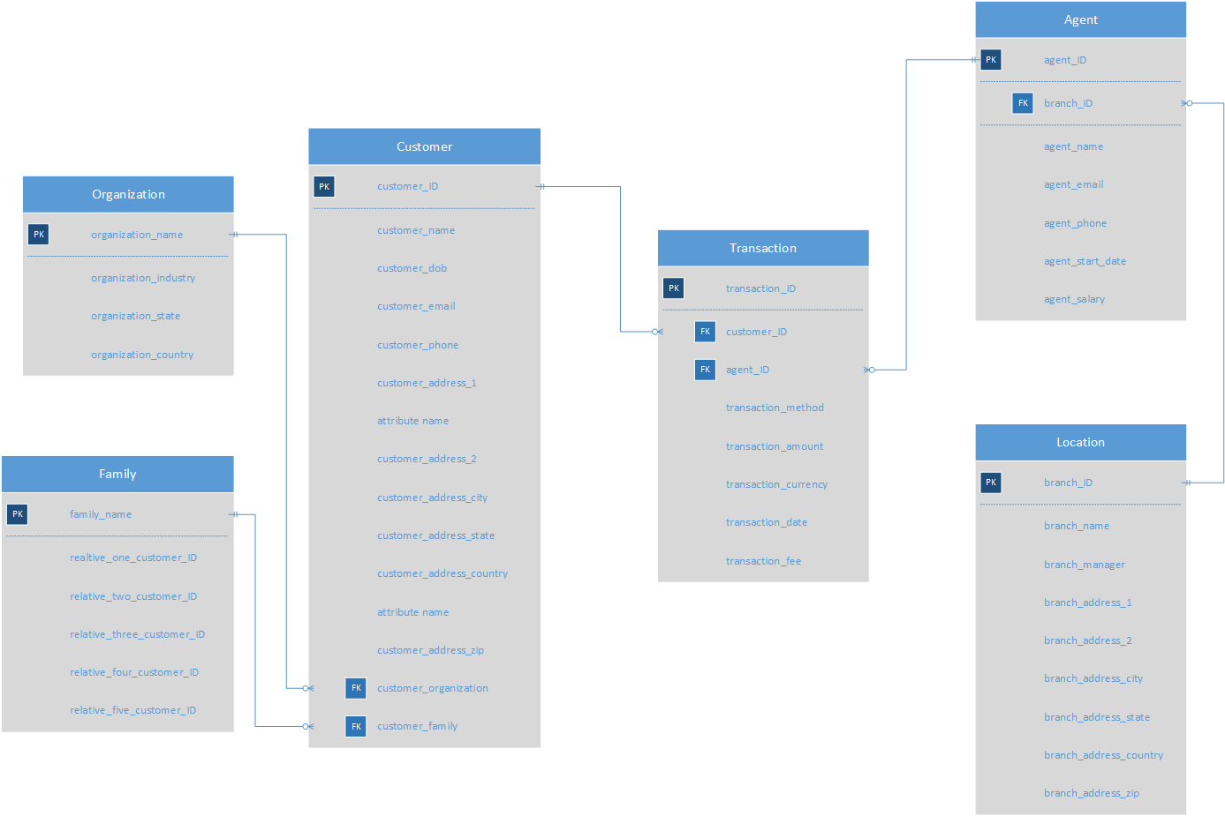

The model above contains six entities in the customer domain that might be involved in any given transaction processed by Third Star Financial Services. The model is centered around the Customer entity which contains foreign keys to the Organization and Family entities. These entities are will not be required for all customers, but any data gathered in these areas can have benefits such as family relationships or common organizations. The Customer entity is also linked to the Transaction entity via the customer_ID attribute. The Transaction entity is linked via the agent_ID attribute to the Agent entity, which is linked via the branch_ID attribute to the Location entity. It is important for accurate data to be allocated to each of the six transactional entities for both operational and analytical Master Data Management purposes.

The operational impacts from this data model would improve business processes for Third Star agents and improve the customer experience. In the current state, the company’s agents have no reliable source of information regarding past and potential recurring customers, but an application, ideally in the Customer Relationship Management realm, could be implemented by drawing from the data in the model. This would allow agents access to a detailed history which could show a customer’s transaction patterns, other agents they have worked with, or preferred contact methods. With this in place, agents could offer tailored services to customers as soon as or even before the customer knows they need it.

The data model would also open additional avenues for standardized reporting and analytical projects. For example, the main reason the Organization and Family components were included is for capitalization from the marketing department. It is reasonable to believe that if one customer is linked to a certain organization or family, their coworkers and relatives would also be more likely to rely on non-traditional banking services than the average person. If Third Star is able to reliably generate relationships between customers and their families or organizations, the marketing department could use this information to target prospects who share those relationships. Additionally, this data model could be the foundation for standard reporting elements used by managers and corporate executives. Including the Transaction, Agent, and Branch components in the data model is essential if Third Star wishes to draw insights towards optimizing efficiency through its business practices. One example of this would be a report that breaks down monthly transaction volume and money movement totals for various agents from a branch location. This report would aggregate data from the Transaction, Agent, and Branch entities, so it is important that each of the attributes are recorded at the transaction level and verified against the master data record.

References:

Berson, Alex. Dubov, Larry. Master Data Management & Data Governance. McGraw-Hill

Education. 2020.

DAMA International. “The DAMA Guide to The Data Management Body of Knowledge.”

Technics Publications, LLC. 2010.